Quantification of the impact of input data uncertainty
The effect that uncertainty in the input data on the across-shelf current was quantified by simulating input data at different uncertainty levels and repeating the across-shelf current calculation.
Uncertainty in the input data was reported as root mean squared difference (RMSD). The uncertainty for the WaveWatch III stokes drift component is 0.03 m (Rascle and Ardhuin, 2013; WAVEWATCH III development group, 2016). Reported uncertainty for GlobCurrent reanalysis product was 0.135 m (this describes the combined uncertainty in the Ekman and geostrophic current vector data) (Chapron et al., 2015; Rio et al., 2016). For regions in which Stokes drift is included in the total current calculation, the total expected uncertainty is therefore calculated as

where ε_{T} is the uncertainty in the total current, ε_{EG} is the combined uncertainty (RMSD) associated with the combined Ekman and geostrophic current input data and ε_{S} is the uncertainty (RMSD) associated with the Stokes drift input data. For regions which did not include a Stokes drift component (e.g. where wind stress was high or significant wave height low), an RMSD of 0.135 m was used.
The effect of uncertainty was assessed at 21 levels by simulating error in the total current. Uncertainty levels were selected to be equally spaced intervals between 0% and 200% of the total expected uncertainty. The simulated error was added to the total current vectors (i.e. independently to the North-South and East-West components) prior to calculating the adjusted Ekman transport vector (due to the Coriolis force) but before the calculating across-shelf current and regional statistics. Errors were modelled using a normal distribution centred at zero with a standard deviation equal to the uncertainty level (root mean squared difference). It is assumed that there are no spatial or temporal correlation in uncertainties. This procedure was repeated 1000 times to characterise the inherent variation at each level of uncertainty.
Regional calculations were performed for each of the shelf sea regions identified by Laruelle et al. (2018)⁠ and the mean and standard deviation of total across-shelf current were calculated using the methodology described in the main text. The absolute difference in total across-shelf current was calculated, from the RMSD = 0 baseline result, for each uncertainty level. An abbreviated version of these results, showing the percentage difference from the baseline result for 6 of the RMSD levels, is shown in Table S1. The full results containing all 21 RMSD levels are provided as a separate supplemental file.
Table S1: Showing the difference in calculated across-shelf current when assuming different root mean squared difference (RMSD) in the input data. Values are calculated as a percentage absolute difference from the baseline (RMSD=0) case, plus/minus the standard deviation. The full results containing all 21 RMSD levels is provided as a separate supplemental file.

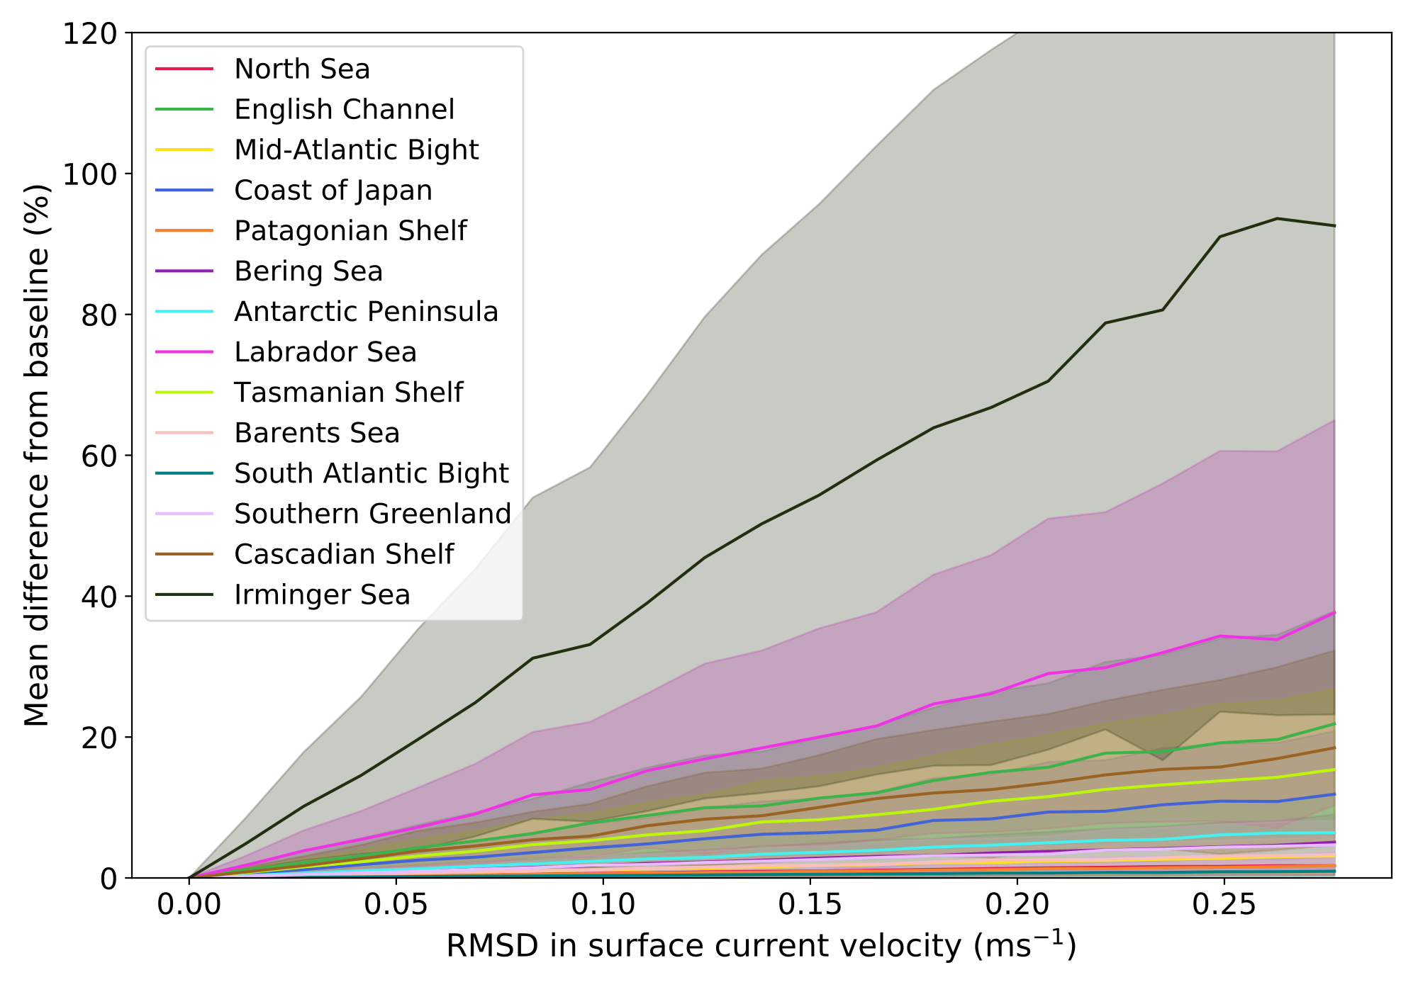
Figure S1: Difference in calculated across-shelf current when assuming different root mean squared difference (RMSD) in the input data. Values are calculated as a percentage of the baseline RMSD=0 (no uncertainty in the inputs). Shaded regions indicate +/- one standard deviation.

References

Chapron, B., Johannessen, J. A., Donlon, C., (2015) GlobCurren Analysis and Interpretation Framework, Version 0.5, Technical note, 36 pp, http://www.globcurrent.nersc.no
Rascle, N., Ardhuin, F., (2013) A global wave parameter database for geophysical applications. Part 2: model validation with improved source term parameterization, Ocean Model., 70, pp. 145-151, 10.1016/j.ocemod.2012.09.001
Rio, M.-H., Johannessen, J., & Donlan, C. (2016). Product data handbook: The combined geostropy+ekman currents (Technical Report). Globcurrent.
WAVEWATCH III development group (2016) User manual and system documentation of WAVEWATCH III version 5.16, Technical Note 329, NOAA/NWS/NCEP/MMAB, College Park, Md, 326 pp.

Expected SKIM error ~ 0.04 m???

